PROJECT REPORT ON

“Preparation and maintenance of ZOHO Books for

Health Hub Medical Clinic

1.INTRODUCTION

1.1 Overview

Our project is preparation and maintenance of ZOHO Books for Health Hub Medical clinic to streamline its financial operations and manage its accounting efficiently. The project involves the preparation and ongoing maintenance of ZOHO BOOKS to ensure accurate financial records and reporting for the clinic

1.2 Purpose

The purpose of this project is to leverage ZOHO BOOKS for Health Hub Medical clinic, aiming to enhance financial management by streamlining operations ensuring accuracy in record-keeping for compliance ,and facilitating transparent reporting

2. problem Definition & Design Thinking 2.1 Empathy Map

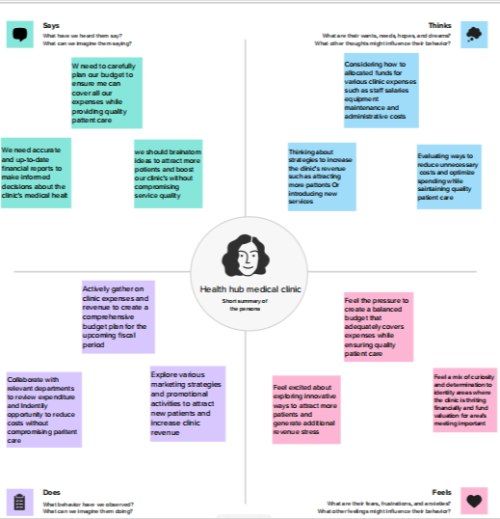

2.2 Ideation & Brainstorming Map

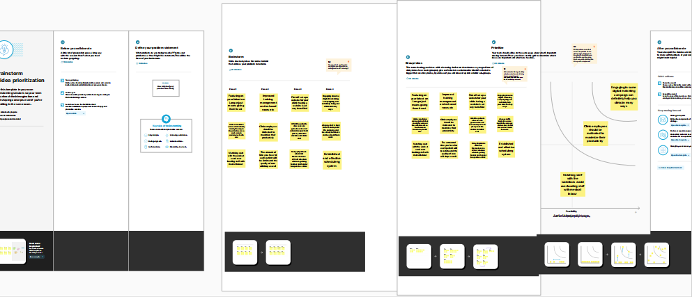

3. Result

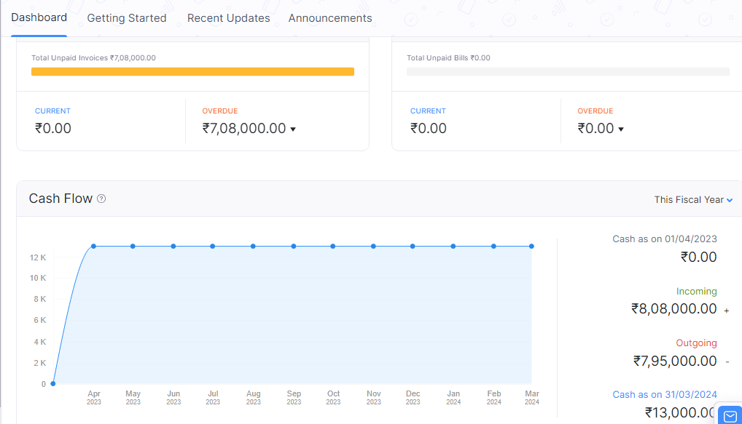

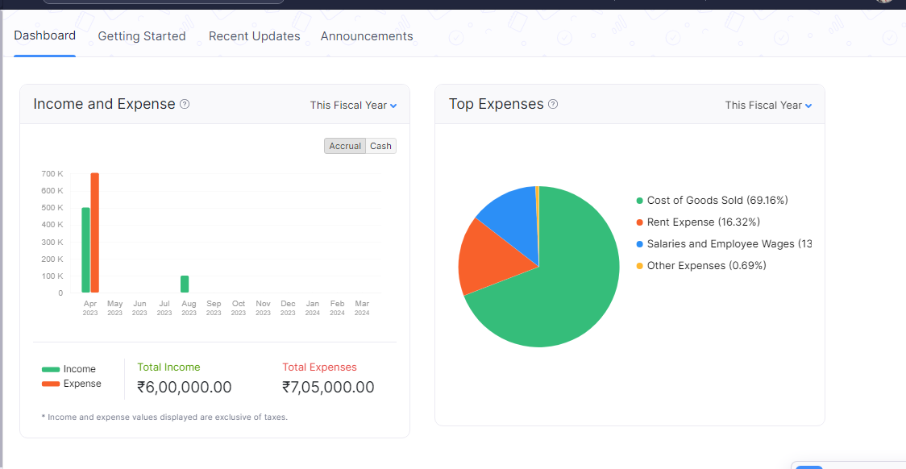

4. ADVANTAGES & DISADVANTAGES

4.1 ADVANTAGES

* Accurate records
* Improved cash flow
* Data security

4.2 DISADVANTAGES

* High cost
* Data migration
* Compatibility issues

**5. APPLICATION**

The solution of preparing and maintaining ZOHO Books is versatile and can be applied across various industries and organization. It is highly applicable to consulting firms, freelancers, e-commerce businesses, and service providers of all kinds.

**6. CONCLUSION**

In conclusion, the project involving the preparation and maintenance of ZOHO Books holds great promise for enhancing financial management across various sectors, including healthcare facilities like Health Hub Medical Clinic, its advantages in terms of efficiency, accuracy and financial reporting make it a valuable assets for small and medium-sized business.

**7. FUTURE SCOPE**

The future scope for a medical health hub is promising, as healthcare continues to evolve and adapt to changing demographics, technologies, and patient needs. A well-organized medical health hub can play a significant role in delivering comprehensive, patient-centric care. Here are some areas where you can anticipate future growth and development.